1. In the below elements which of them are values or an expression? eg:- values can be

integer or string and expressions will be mathematical operators.

\*

‘hello’

-87.8

-

/

+

6

Ans: \* expression

‘hello’ value

-87.8 value

- expression

/ expression

* expression

6 value

2. What is the difference between string and variable?

Ans: A Variable is a store of information, and a String is a type of information you would store in a Variable.

String: String can be written in single or double quotes . eg: "Pallabi", 'Polly'

Variable : 2,-8,7098

3. Describe three different data types.  
  
Ans: STRING: String is a type of information you would store in a Variable.

String can be written in single or double quotes . eg: "maa", 'baba'  
  
INTEGER: it can be a whole number . eg: 45,-78

FLOAT: normally decimal numbers . eg: 7.99  
  
Boolean : eg: True, False   
  
List: Lists are used to store multiple items in a single variable. eg: [1,2,3]

TUPLES:   
Tuples are used to store multiple items in a single variable.  
eg:(1,2,4,6)  
  
  
Dictionaries: these are used to store data values in key:value pairs.   
eg: {"a":1, "b":2, "c":3}  
  
  
4. What is an expression made up of? What do all expressions do?

ANS: An expression is a combination of operators and operands that is interpreted to produce some other value. In any programming language, an expression is evaluated as per the precedence of its operators.

Expressions are representations of value. They are different from statements in the fact that statements do something while expressions are a representation of value. For example any string is also an expression since it represents the value of the string as well.

5. This assignment statements, like spam = 10. What is the difference between an

expression and a statement?

Ans: Expression is made up of values, containers, and mathematical operators (operands) and the statement is just like a command that a python interpreter executes like print.

6. After running the following code, what does the variable bacon contain?

bacon = 22

bacon + 1

Ans: 23

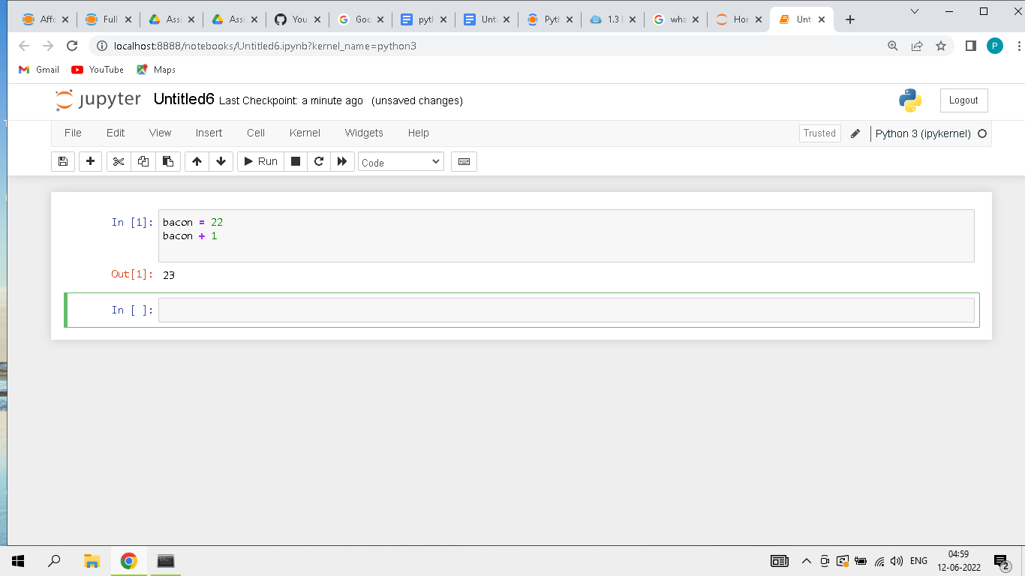

7. What should the values of the following two terms be?

‘spam’ + ‘spamspam’

‘spam’ \* 3

Ans:

'spamspamspam'

'spamspamspam'

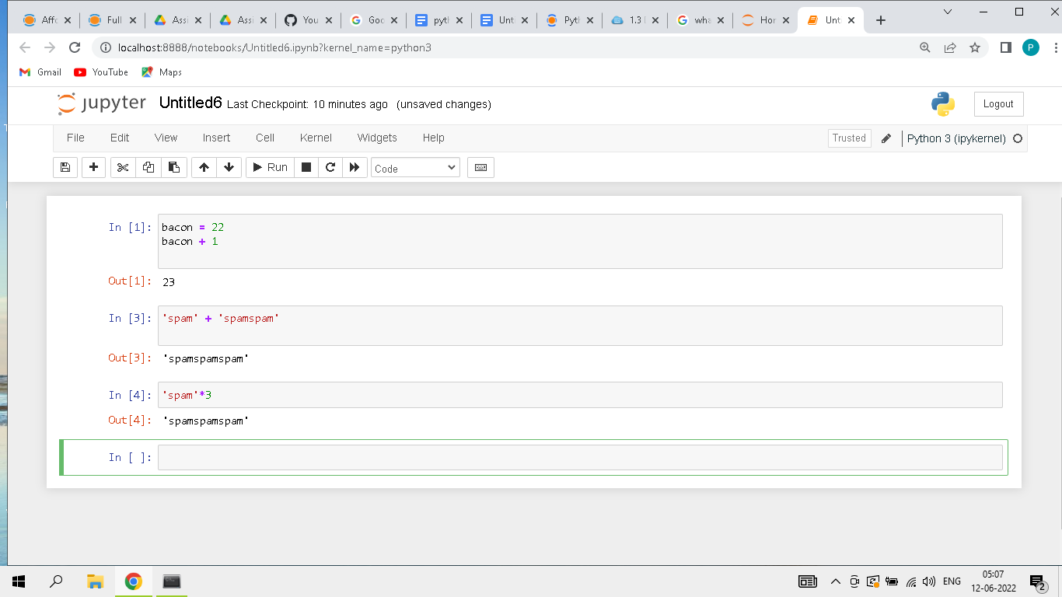  
  
  
  
8. Why is eggs a valid variable name while 100 is invalid?

Ans: because eggs is not any number ,integer,float or any kind of data type which the compiler knows .. but 100 can not be a name because it's an integer value which the compiler knows. If we add any alphabet in beginning like p100 then it can be valid

9. What three functions can be used to get the integer, floating-point number, or string

version of a value?

Ans: int() , str() ,float()

10. Why does this expression cause an error? How can you fix it?

‘I have eaten’ + 99 + ‘burittos.’

Ans: in python addition can happen with the same data type only , here two are strings but one is integer value . if we ‘99’ did this then it will be correct.

‘I have eaten’ +’ 99’ + ‘burittos.’